**UI Screens :**

Admin Dashboard - System overview with KPIs

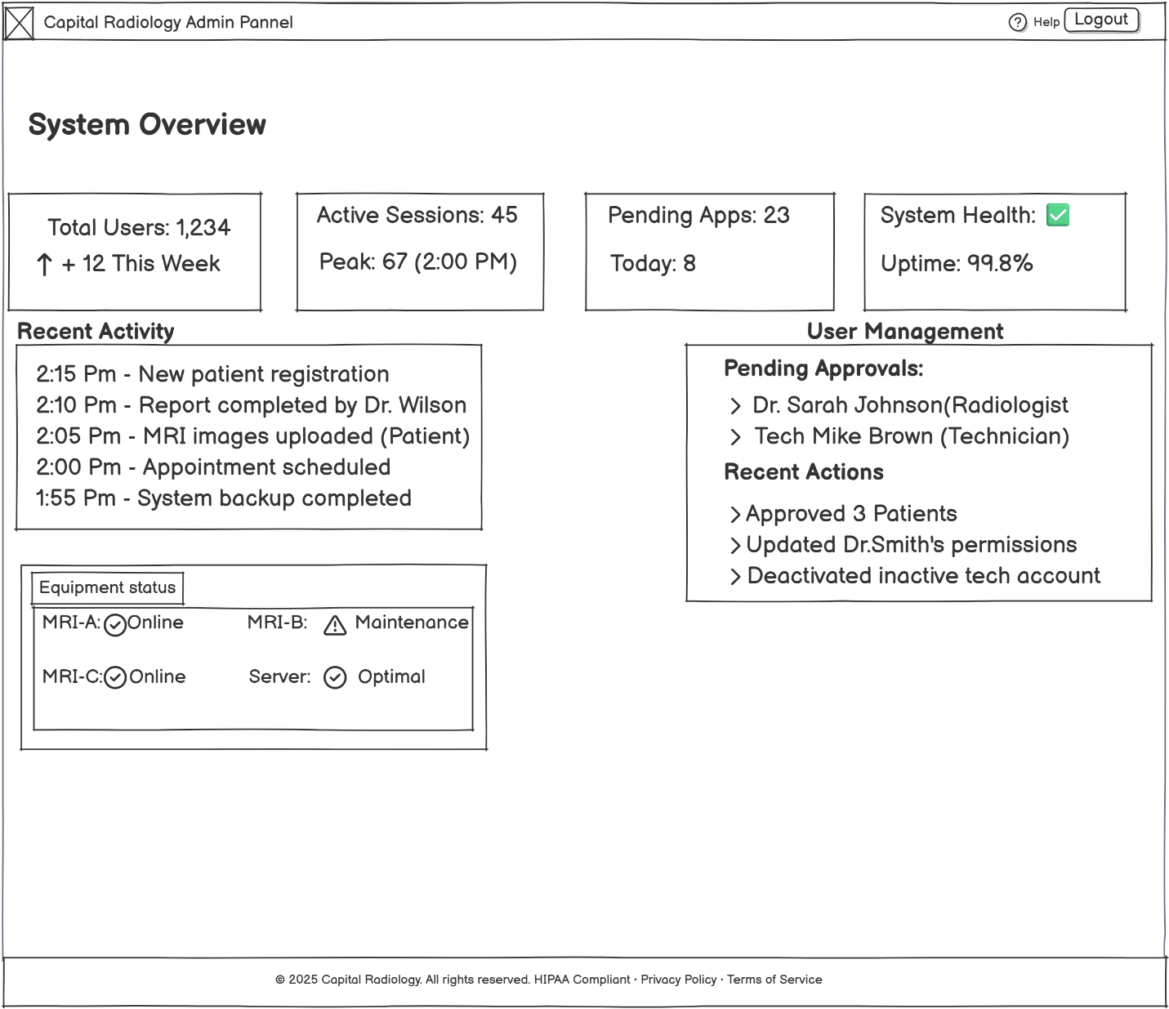

User Management - Account creation and role assignment

System Analytics - Performance metrics and usage reports

Security Settings - Access control and audit logs

**Forms Design :**

Input Form: User account creation form

Input Form: System configuration panel  
  
Output Form: Analytics dashboard layout

Output Form: Security audit report

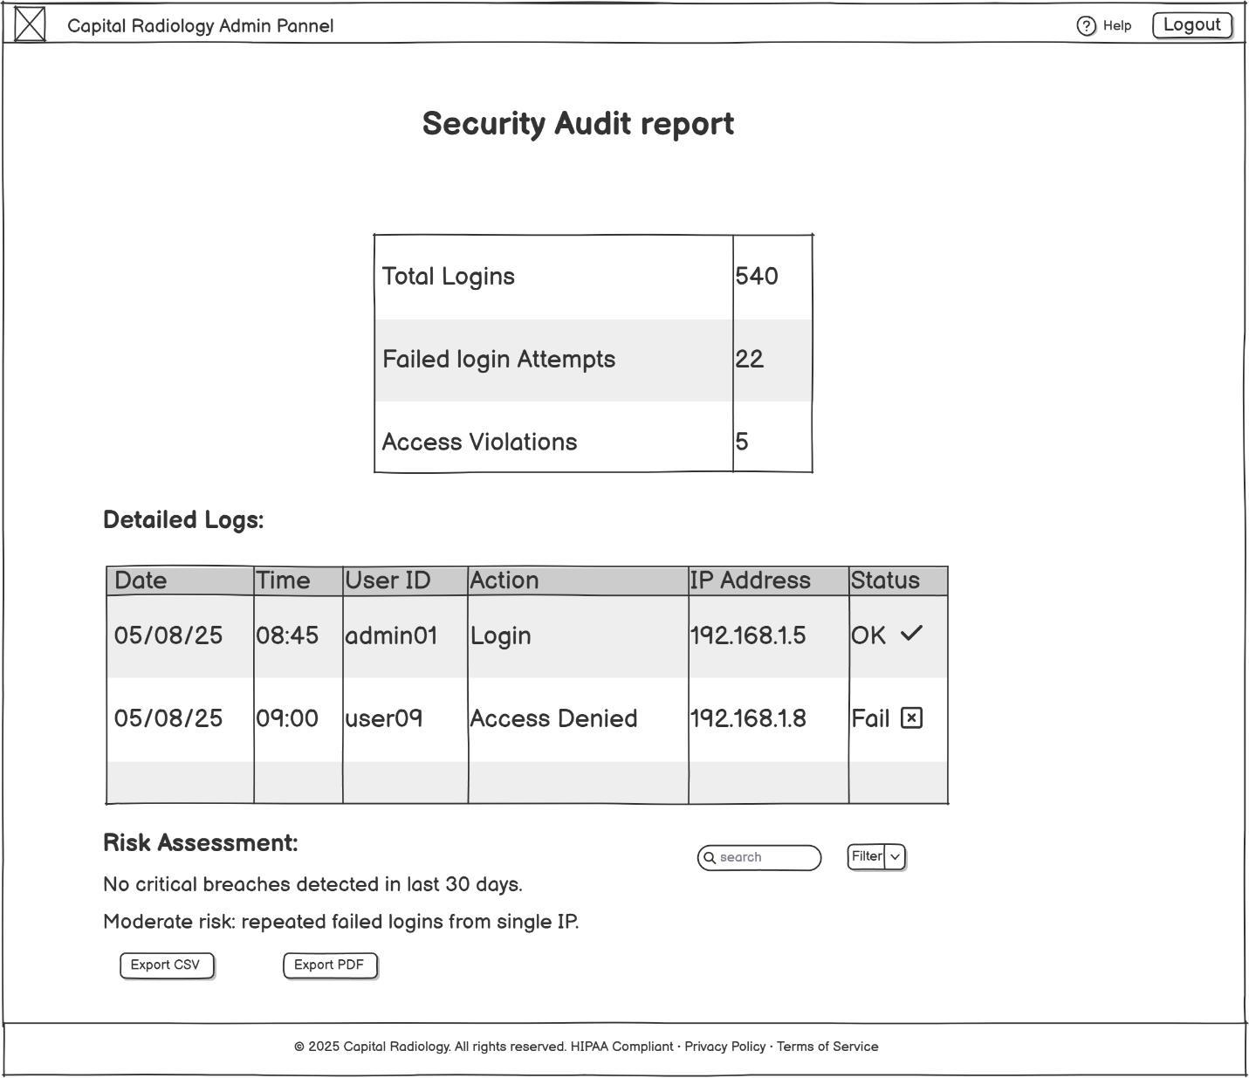

**Storyboard: System administration workflow (4-step user flow)**

